The purpose of this script is to take a **cell_seg_data.txt** file for a single high powered field and that high powered field’s corresponding **Phenotype.tif** file (the file with the phenotypes overlaid on top the composite image) and draw nearest neighbor clusters within a certain radius. The output will be a .tif file with lines connecting nearest neighbors within a certain radius on top of the original Phenotype.tif file. The name of the image will be in the format of **“[phentoype2]_within_25_microns_of_[phenotype1]”**. This means that there are lines radiating from each cell of phenotype1 to all of the members of phenotype2 that are within 25 microns of phenotype1. If there are duplicates (i.e. a member of phenotype2 is within 25 microns of multiple members of phenotype1), the line will be assigned to the nearest neighbor within the shortest distance.

**Classic workflow: Complex_Phenotype.R (if needed) -> NN_Cluster_Image.R**

1. The folder **NN** should have four subfolders: **Files**, **Images**, **Results_Flipped**, and **Final_Results**.
   1. Check to make sure the NN folder with the four subfolders in it is in the working directory (the stuff inside the **setwd()**, **list.files()**, **image_write()**, and **tiff()** functions). There may be other subfolders but these are the only necessary ones.
      1. If it is not in the working directory, change your working directory in the areas boxed in red below to wherever the NN folder is.
      2. Do not change the “_within_25_microns_of_” part in the tiff() function
      3. Make sure to keep the slashes **“/”** at the end of the string (the stuff inside the quotes in green) when there is a **paste** function or the directory will be incorrect.

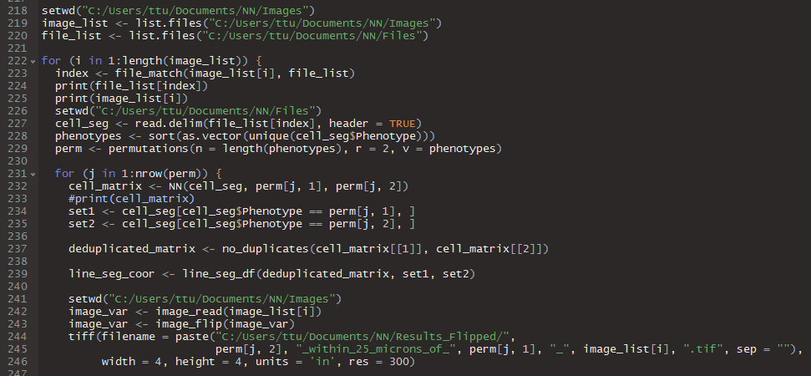

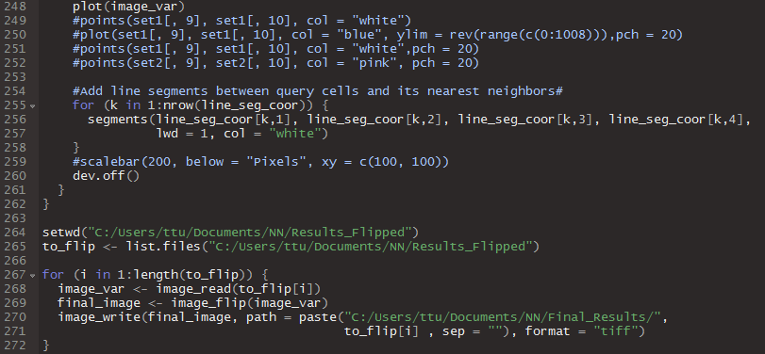

1. The **Files** subfolder should contain **cell_seg_data.txt** files **FOR INDIVIDUAL HIGH POWERED FIELDS**. The **Images** subfolder should contain **Phenotype.tif** files **FOR THE HIGH POWERED FIELDS CORRESPONDING TO THE CELL_SEG_DATA.TXT FILES**. Before running the **Final_Results** and **Results_Flipped** subfolder should be empty. This is where your results will go.
   1. Make sure the cell_seg_data.txt files are “Tab Delimitated”. If they are not (if they were exported from Spotfire they might be Unicode), ask Anthony or Ting-Fang for a script to change them or you can open them in Excel and “Save As”, “Save as type: **Text (Tab delimited) (*.txt)**”
   2. Make sure the Phenotype.tif files are “.tif” files. The script is looking for tiff files specifically using the image_read() function. You can use ImageJ to convert an image to a tiff file by opening it and then saving it by File -> Save As -> Tiff…
2. If you need to change the dimensions of the image:
   1. The parameters in the red box indicate that the tif file being created will have a width of 4 inches, a height of 4 inches and a resolution of 300 dpi.
   2. The units parameter also has an option for pixels which you could use by replacing “units = ‘in’” with “units = ‘px’” and then changing the width and height dimensions. Make sure to use a string for the units parameter (inside quotes and should turn green at least in my RStudio view).
   3. You can change res, width, and height by entering positive real numbers.
3. If you want to change the colors or size the lines connecting the nearest neighbor clusters:
   1. The parameters in the yellow box below control how thick and what color the lines are. Currently the thickness is set at “lwd = 1” and the color is white (col = “white).
   2. To change the thickness, replace the “lwd = 1” with “lwd = any positive real number” (the larger the number the thicker the line).
   3. To change the color replace the col = “white” with any color you can think of inside the string (in quotes). R will throw an error it does not recognize it. You can look online to find what colors R supports.

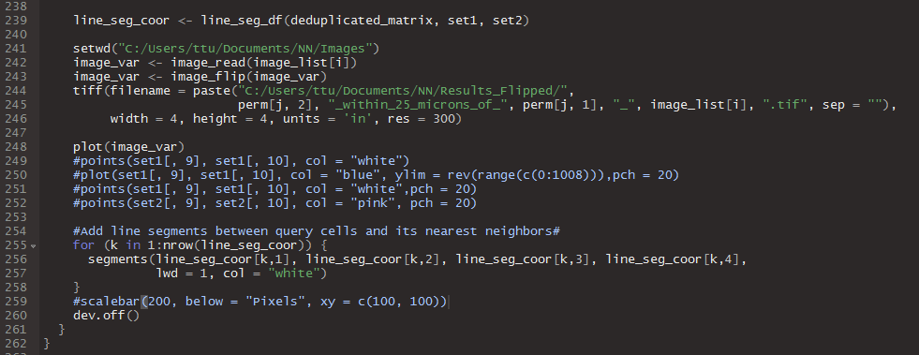

1. NOTE: There is an optional line of code in the blue box above. It is currently commented out (It is in in blue in my RStudio view and is the stuff that comes after the “#”) so it is not being run. It allows for the creation of a scalebar that should read “200 Pixels” at the (100, 100) position on the image (somewhere in the bottom left). You can use it to make a scalebar on the image but *I highly recommend avoiding it because I could not get the text to work properly*.
2. Click the “Source” button in the top right of the RStudio scripting window to run the script!

Note: If you are having trouble getting the finding the high powered field cell_seg_data.txt or the composite image overlaid with the phenotypes you can ask Ting-Fang to help with exporting that data from an inForm project or to deep dive into folders to find long lost data.